App name: Instagram
- Description
Instagram is a simple way to capture and share the world moments. Follow your friends and family to see what they are up to, and discover accounts from all over the world that are sharing things you love. Join the community of over 500 million people and express yourself by sharing all the moments of your day the highlights and everything in between, too.
Use Instagram to:
Post photos and videos you want to keep on your profile grid. Edit them with filters and creative tools and combine multiple clips into one video.
Share multiple photos and videos (as many as you want!) to your story. Bring them to life with text and drawing tools. They disappear after 24 hours and won’t appear on your profile grid or in feed.
Go live to connect with your friends and followers right now. When you are done, live stories disappear.
Send disappearing photos and videos, text messages and posts from your feed to groups and friends with Instagram Direct.
Watch stories and live videos from the people you follow in a bar at the top of your feed.
Discover stories, photos and videos you might like and follow new accounts on the Explore tab.

- Goal Model
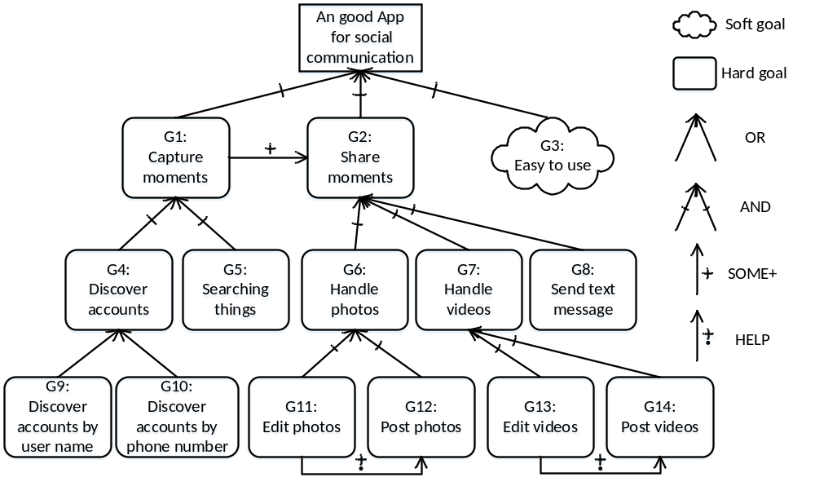
- The description of each goal

ID | Des | Type
G1 | Capture moments and follow your friends and family to see what they are up to | Hard goal
G2 | Share moments: share things you love | Hard goal
G3 | Easy to use | Soft goal
G4 | Discover accounts from all over the word | Hard goal
G5 | Searching the things by inputting key words | Hard goal
G6 | Handle photos | Hard goal
G7 | Handle vides | Hard goal
G8 | Send text message | Hard goal
G9 | Discover accounts by inputting user name | Hard goal
G10 | Discover accounts by inputting phone number | Hard goal
G11 | Edit photo, including its color, light, contrast. | Hard goal
G12 | Post photos to your profile grid | Hard goal
G13 | Edit video, adjusting its color, light and contrast, and combine multiple clips into one video | Hard goal
G14 | Post video to your profile grid | Hard goal

